- This week’s UK data releases provided the Monetary Policy Committee with extra leeway to keep Bank Rate on hold while it assesses the risks of a more persistent inflationary shock.
- CPI inflation surprised to the downside in April, with smaller-than-expected rises in regulated and indexed prices baking in lower inflation in these categories for the next year. Pay growth cooled further, while there were clear signs the jobs market is continuing to loosen. Indeed, evidence of demand weakness suggests labour market conditions will likely loosen further this year.
The Monetary Policy Committee has been in wait-and-see mode, but the raft of data releases published this week promised to provide the first real test of that stance. We think the data is likely to have reinforced the MPC’s desire to keep Bank Rate on hold over the summer.
The week’s most noteworthy release was April’s inflation data. April has become a crucial month for inflation, with a variety of regulated and inflation-linked prices, such as phone contracts, changing that month. Many of these prices only change once a year, so April’s outturn has outsized importance for the following 11 months.
This year’s price hikes for these categories were smaller than we and most other forecasters anticipated. Coming alongside a 7% fall in the energy price cap, a temporary drop in air fares, and a genuine cooling in underlying price pressures in the services sector, this meant CPI inflation fell to 2.8% in April, from 3.3% in March (Chart 1).
Chart 1: Lower services inflation wasn’t just a story of smaller rises in indexed and regulated prices
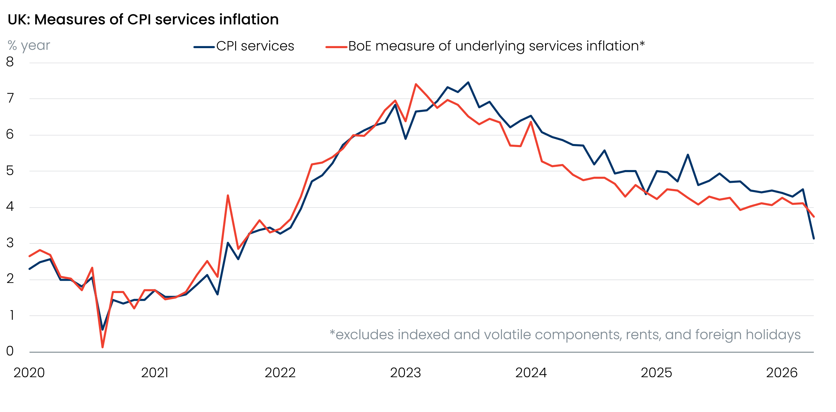
Source: Oxford Economics calculations using data from Haver Analytics

Despite this week’s better inflation news, there’s still plenty of price pressures in the pipeline. Oil prices remain elevated, while movements in wholesale gas prices are on track to deliver a double-digit jump in the energy price cap in July, with a further rise likely in October. Higher oil and gas prices will also push up input costs for firms, some of which will be passed on to consumers over the course of the year. So while April’s softer-than-expected rises in regulated and indexed prices should lower the peak for inflation, we still forecast CPI inflation will climb above 4% in the final months of 2026.
Key to the monetary policy outlook is the extent to which this burst of high inflation will generate second-round effects via higher pay growth. Tuesday’s labour market release will have provided some reassurance on this score. Pay growth continued to cool, with headline private sector regular pay growth edging down to 3% in the three months to March. The three-month-on-three-month annualised rate – a better guide to recent momentum – fell much more sharply.
On the quantities side, HMRC’s count of payrolled employees plunged by 100,000 in April. We suspect this overstates the weakness – history suggests weak initial outturns for April tend to be revised smaller over time (Chart 2). But job vacancies also continued to decline and overall, we view the latest pay and jobs data as being consistent with a labour market that is continuing to loosen. This message was reinforced by May’s flash S&P Global survey, which reported further job shedding.
Chart 2: History suggests April’s large drop in employees on payrolls may be revised much smaller over time
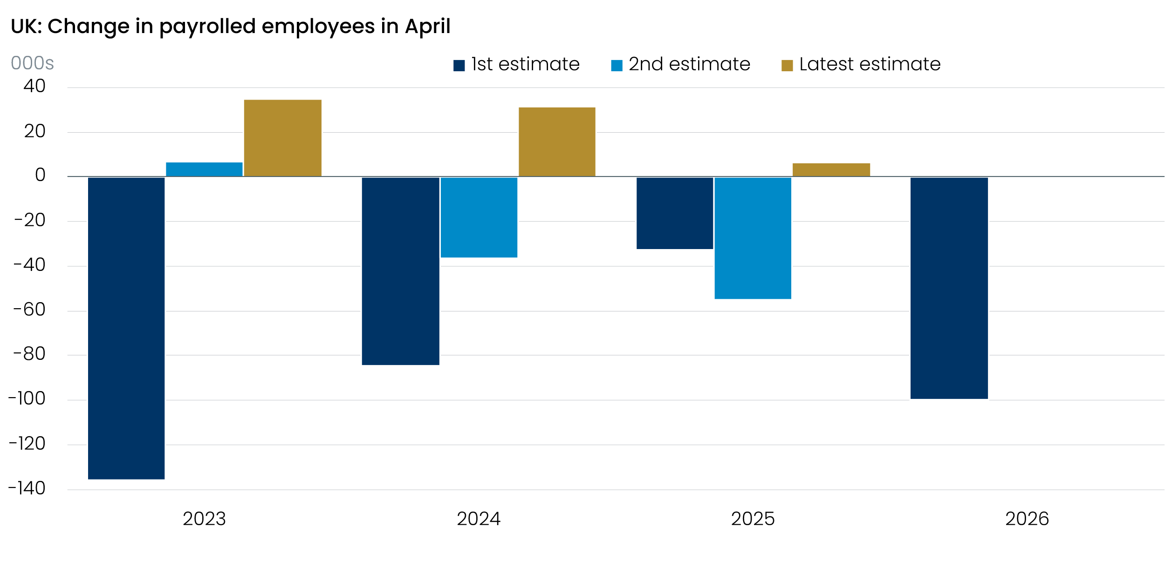
Sources: Oxford Economics, Haver Analytics
Demand weakness threatens to trigger further loosening in labour market conditions. The composite PMI collapsed to a 13-month low in May, with respondents reporting that investment and consumer spending decisions were being delayed in response to the Middle East conflict. And retail sales fell sharply in April, as March’s surge in fuel sales more than unwound. Both measures have significant flaws, and it’s never wise to read too much into single readings. But the data back our view that activity will slow abruptly mid-year, after residual seasonality exaggerated the strength of Q1.
With no sign that underlying price pressures are building and evidence that activity is weakening, the MPC can keep Bank Rate at its current restrictive level as it waits for more information about how energy prices will evolve, and how this shapes firms’ price- and wage-setting behaviour.

The week ahead
There are no major releases next week.
Table 1: Week ahead calendar
Date | Events | Period | Measure | Unit | Previous | Forecast
May 29 | Nationwide house prices | May | m/m | % | 0.4 | -0.2
May 29 | Nationwide house prices | May | y/y | % | 3.0 | 2.2
Source: Oxford Economics

Key forecasts
Table 2: UK forecast overview
(ANNUAL PERCENTAGE CHANGES UNLESS SPECIFIED)
 | 2024 | 2025 | 2026 | 2027 | 2028 | 2029
GDP | 1.0 | 1.4 | 0.7 | 0.7 | 1.8 | 1.7
Private consumption | -0.1 | 0.8 | 0.6 | 0.4 | 1.5 | 1.8
Fixed investment | 1.7 | 4.3 | 0.3 | 1.5 | 2.5 | 2.1
Government consumption | 2.9 | 1.6 | 1.3 | 1.6 | 1.4 | 1.2
Consumer prices | 2.5 | 3.4 | 3.4 | 2.7 | 1.9 | 2.0
Unemployment rate (%) | 4.3 | 4.9 | 5.4 | 5.6 | 5.1 | 4.7
Current a/c balance (% of GDP) | -3.0 | -2.4 | -3.8 | -3.2 | -2.6 | -2.5
Government balance (% of GDP) | 5.2 | 5.0 | 4.0 | 3.8 | 3.0 | 2.6
Central bank policy rate (%, EOP) | 4.75 | 3.75 | 3.75 | 3.50 | 3.00 | 2.75
10yr govt. bond yield (%, EOP) | 4.57 | 4.47 | 5.13 | 4.57 | 3.87 | 3.55
Exchange rate (US$ per £, EOP) | 1.25 | 1.35 | 1.30 | 1.30 | 1.30 | 1.30
Exchange rate (euro per £, EOP) | 1.21 | 1.15 | 1.12 | 1.10 | 1.10 | 1.10
Source: Oxford Economics
Table 3: Quarterly forecasts for the UK
 | 2026 |  |  |  | 2027
 | Q1 | Q2 | Q3 | Q4 | Q1 | Q2 | Q3 | Q4
GDP (% year) | 1.1 | 0.9 | 0.6 | 0.4 | 0.2 | 0.5 | 1.0 | 1.3
CPI inflation (% year) | 3.1 | 3.0 | 3.6 | 3.9 | 3.7 | 3.0 | 2.3 | 1.9
Bank Rate (%, EOP) | 3.75 | 3.75 | 3.75 | 3.75 | 3.75 | 3.75 | 3.75 | 3.50
10yr gilt yield (%, EOP) | 4.88 | 5.10 | 5.14 | 5.13 | 5.09 | 4.96 | 4.78 | 4.57
US$ per £ (EOP) | 1.32 | 1.34 | 1.32 | 1.30 | 1.30 | 1.30 | 1.30 | 1.30
Euro per £ (EOP) | 1.14 | 1.16 | 1.14 | 1.12 | 1.11 | 1.10 | 1.10 | 1.10
Source: Oxford Economics

Latest Country Economic Forecast:
May 21, 2026

Recent publications

Data Insights
Public finances softer than expected
Weaker retail sales in April supports the case for Q2 slowdown
May’s flash PMIs signal a pullback in private sector activity
Inflation softened temporarily in April
Jobs market continues to cool

Research Briefings
Are European countries with high AI use seeing higher productivity growth?
Weak real incomes set to subdue consumer spending
Why 5% 10-year gilt yields are here to stay
MPC maintains a watching brief, but chances of higher rates are rising
Residual seasonality issues continue to flatter activity growth in Q1

Contacts

Oxford Economics' UK team
- Andrew Goodwin – Chief UK Economist – agoodwin@oxfordeconomics.com
- Edward Allenby - Senior UK Economist - eallenby@oxfordeconomics.com

